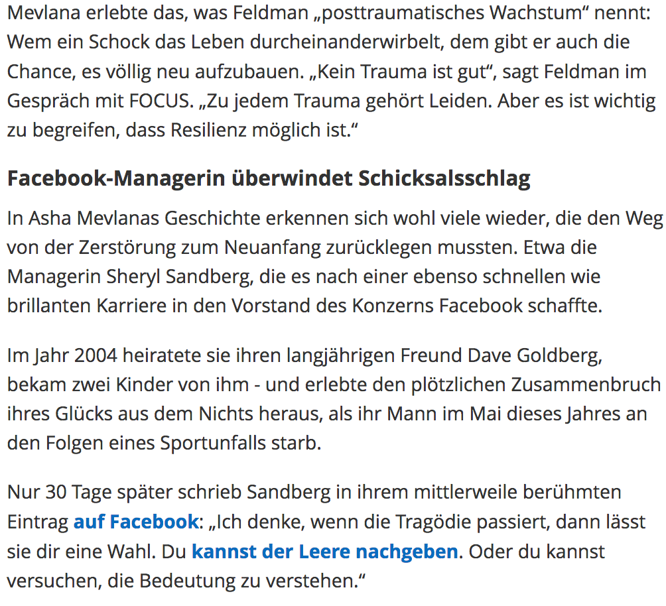

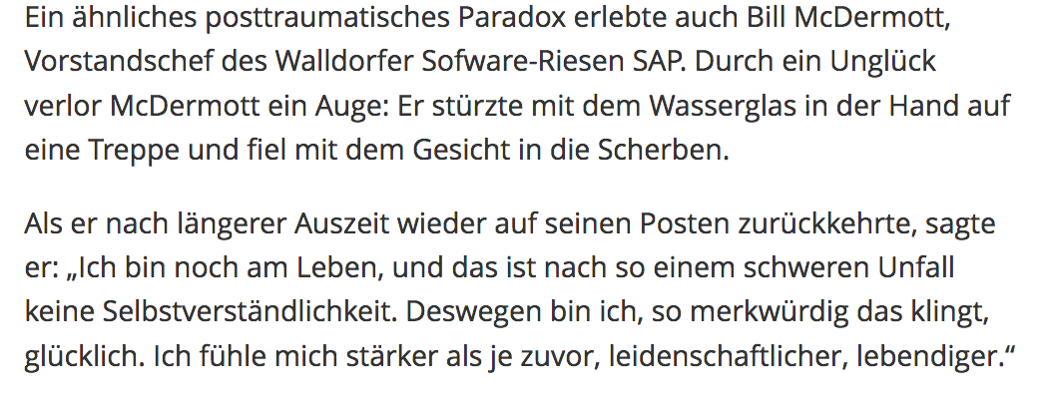

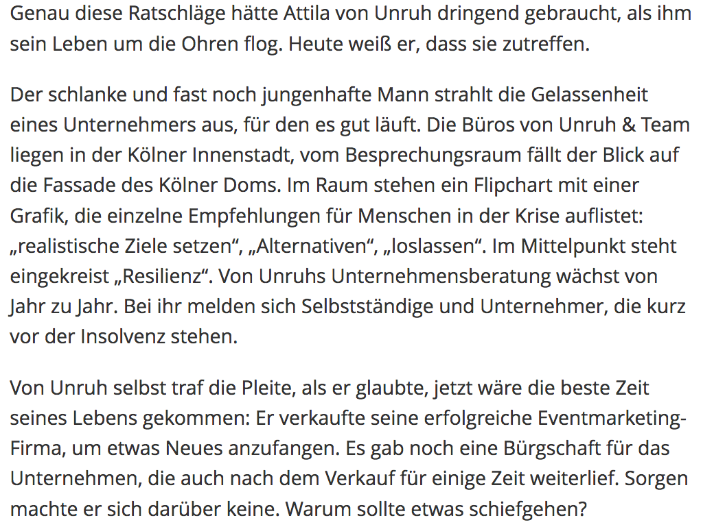
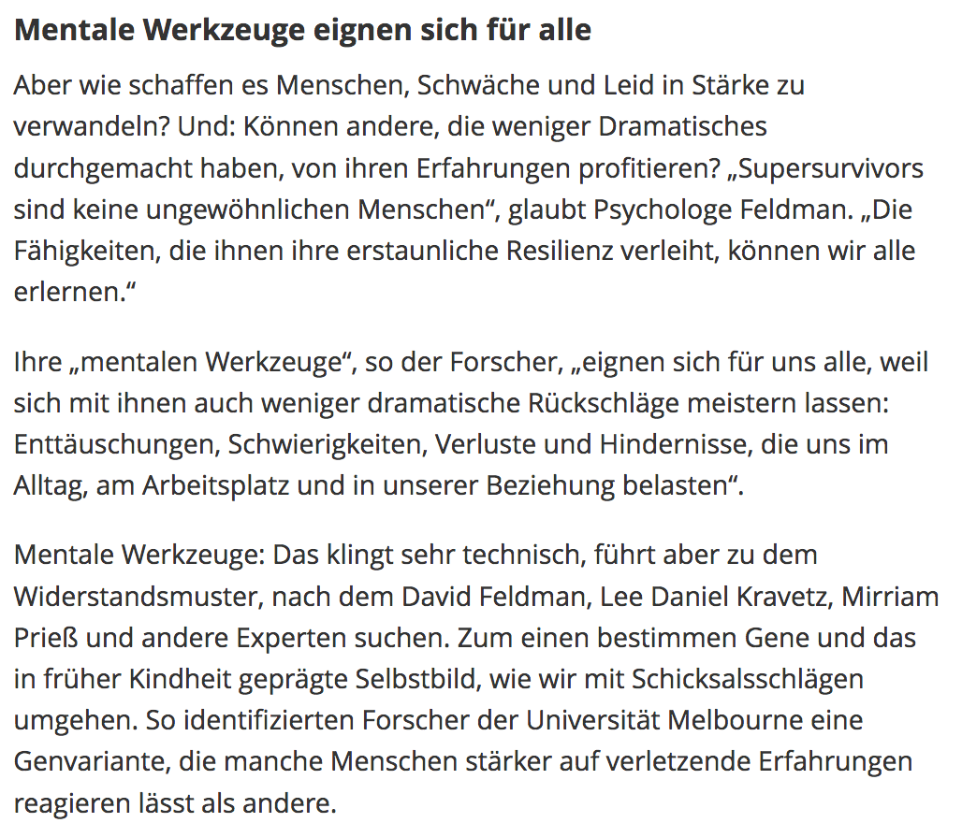
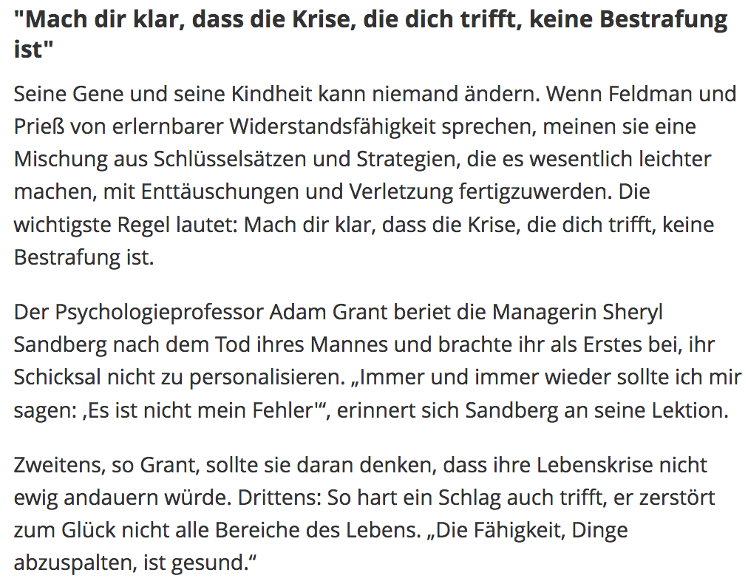

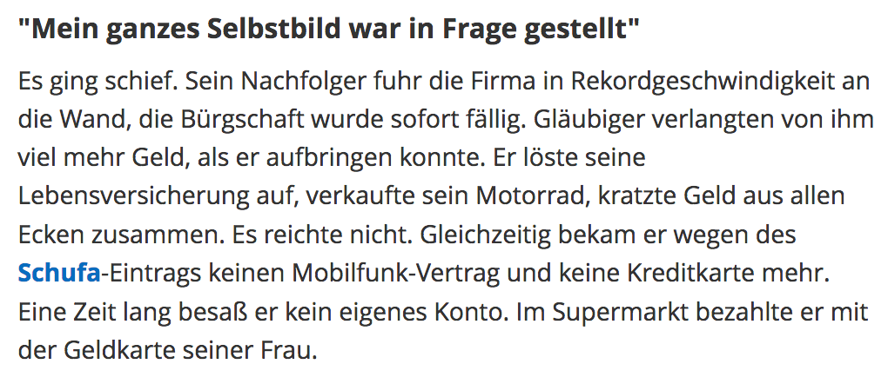

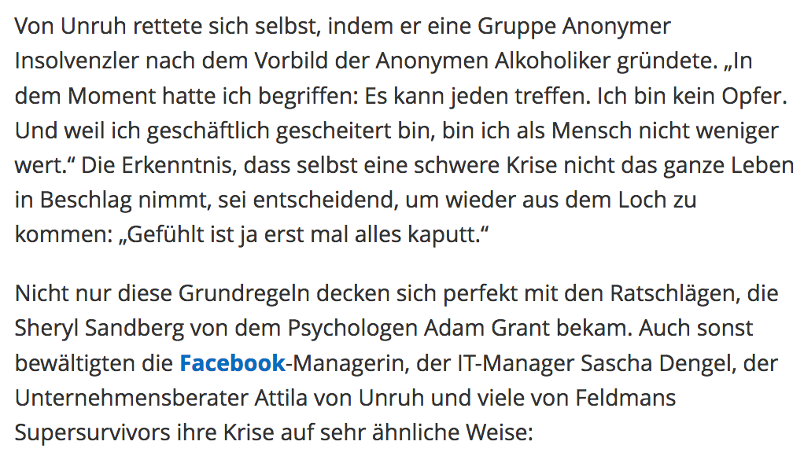

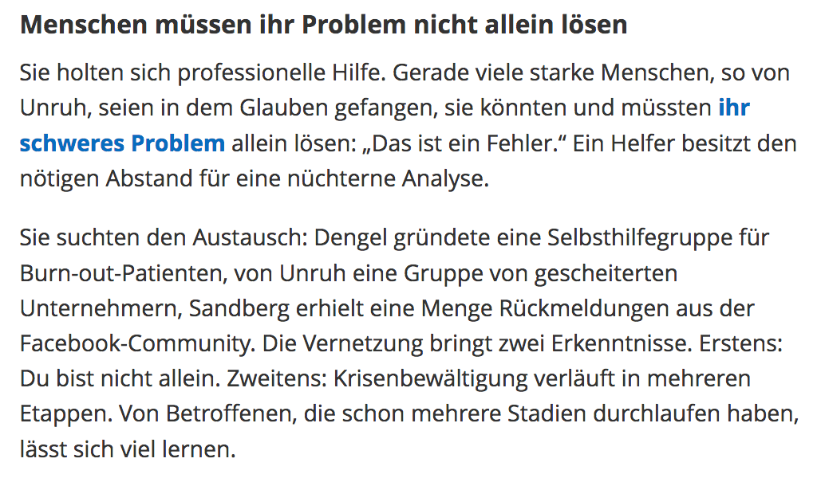

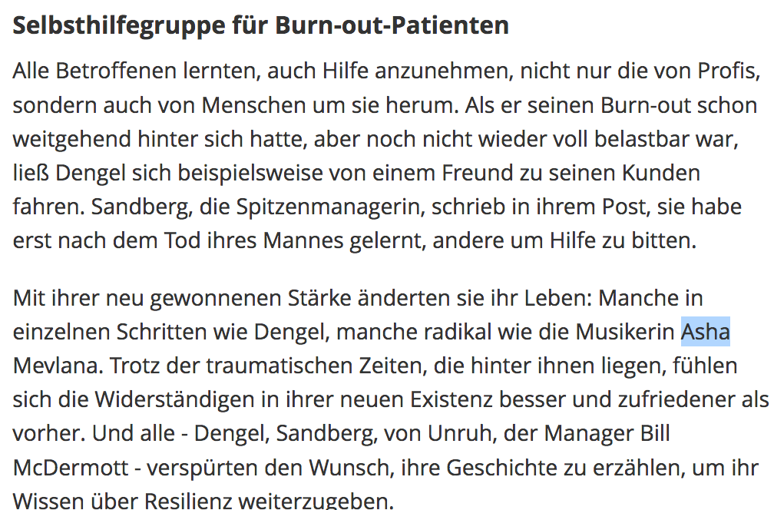

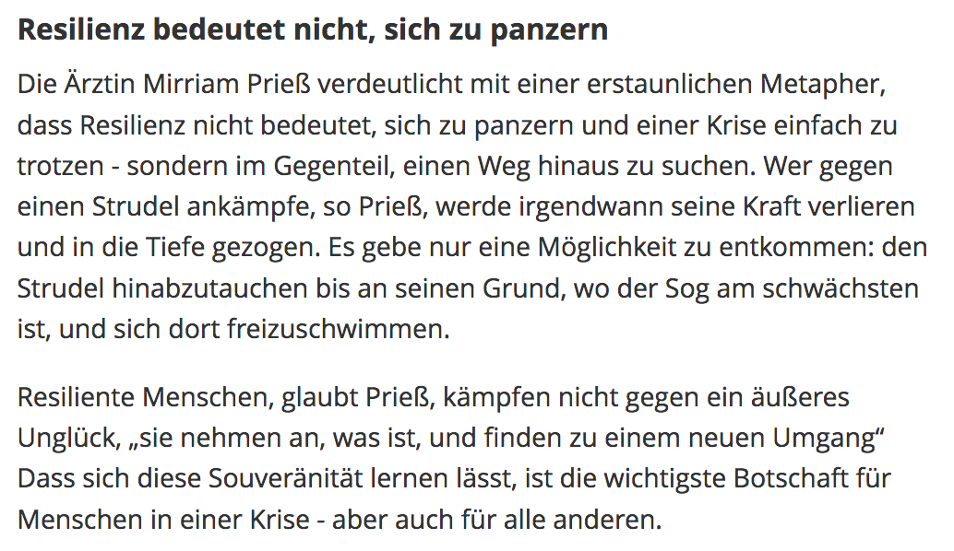

TRANSLATION:

But how do some people succeed in building strength even under extreme pressure? The book "Supersurvivors" by the American psychologists David Feldman and Lee Daniel Kravetz tells of people who came to a new strength through an existential crisis - to become "super-survivors". Caught in burn-out Like Asha Mevlana: The New Yorker had just started a career in a start-up when she was diagnosed with breast cancer at 24. She tolerated the treatment with all the side effects without complaint. When the doctor told her that the tumor had disappeared, however, she was almost shocked: she understood that she had repelled her earlier existence with the disease, and that the question of plans and goals was now being completely revised. From this point onwards, the young woman devoted herself to her great passion, the acting, which she had intensified during her therapy. Soon she became a member of a band, played with stars such as Alanis Morissette and Jay Z, and appeared in programs such as "American Idol" in front of a million-plus audience.

Mevlana experienced what Feldman calls "posttraumatic growth." To whom a shock intertwines life, he also gives the chance to rebuild it completely. "No trauma is good," says Feldman in conversation with FOCUS. "To every trauma belongs suffering. But it is important to understand that resilience is possible. " Facebook-manager overcomes fate In Asha Mevlana's story, many people are recognizing the path from destruction to a new beginning. The manager, for example, Sheryl Sandberg, who succeeded in the company's board of directors after a brilliant and brilliant career. In 2004 she married her longtime friend Dave Goldberg, got two children from him - and experienced the sudden collapse of her happiness out of nowhere when her husband died in May of this year due to a sports accident. Only 30 days later, Sandberg wrote in her now famous entry on Facebook: "I think if the tragedy happens, it leaves you with a choice. You can give in to emptiness. Or you can try to understand the meaning. " Emotional text hit a nerve Her emotional text, which deeply injured an unusual look in Sandberg's, but at the same time allowed such a monstrously robust soul, obviously hit a nerve: he has been lured nearly a million times and divided 400,000 times. Whether it is a life-threatening disease, the loss of a loved one, professional failure or a serious accident - traumatic experiences can be quite different - the patterns of the resulting resilience resemble each other amazingly strongly. The Cologne entrepreneur Attila von Unruh experienced the business and social crash and now coaches insolvent businessmen and bankruptcy nationwide. And not only that, he also changed his priorities. He always advises clients also fee-free and comes after his reboot with significantly less money than before. "What I am doing now," he says, "gives me a different kind of satisfaction."

With their new strength they changed their lives: some in individual steps like Dengel, some as radical as the musician Asha Mevlana. Despite the traumatic times that lie behind them, the righteous ones feel better and happier in their new existence than before. And all - Dengel, Sandberg, von Unruh, the manager Bill McDermott - felt the desire to tell their story to share their knowledge of resilience. Resiliency does not mean to arm yourself The doctor Mirriam Prieß shows with an astonishing metaphor that Resilienz does not mean to arm herself and defy a crisis simply - on the contrary, to look for a way out. Anyone struggling against a whirlwind, Priess, would at some time lose his strength and pull it into the depths. There was only one way to escape: to descend the whirlpool to the bottom where the suction is the weakest, and to float there. Resieted people, Prieß, do not fight against an external misfortune, "they accept what is, and find a new deal". The fact that this sovereignty can be learned is the most important message for people in a crisis - but also for everyone else .

