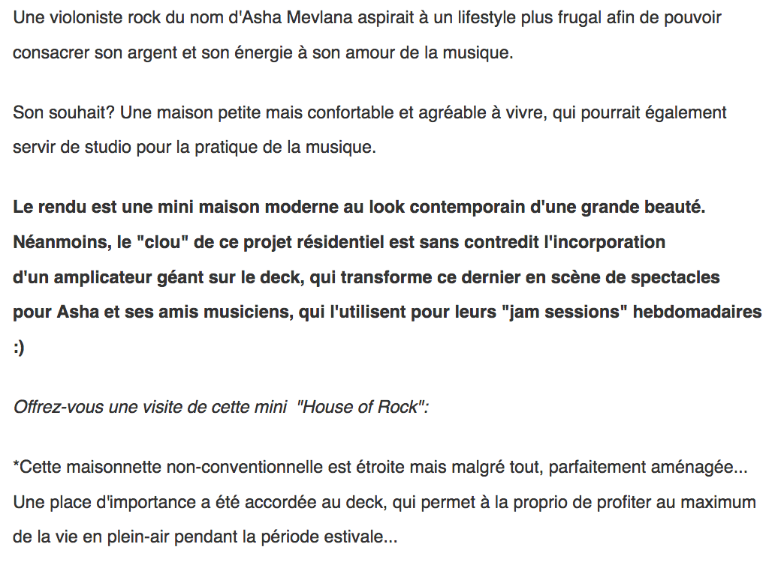

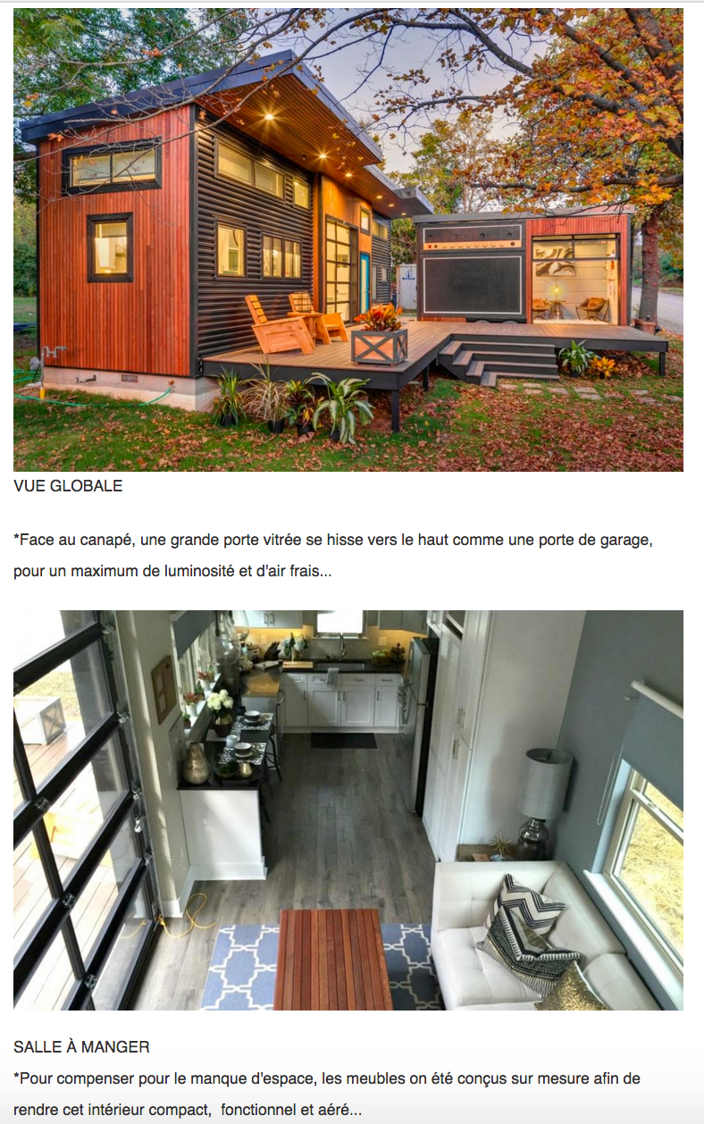

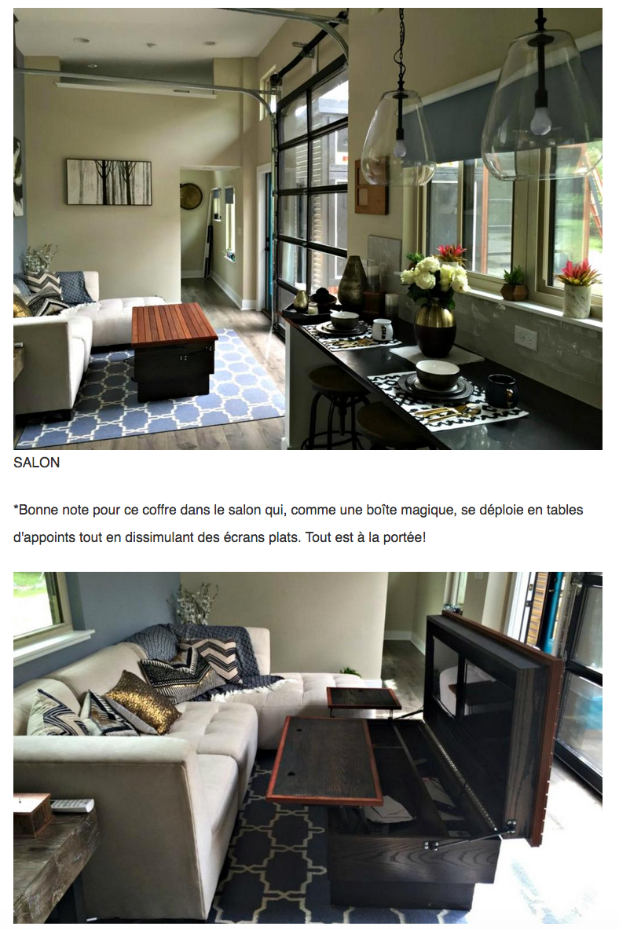

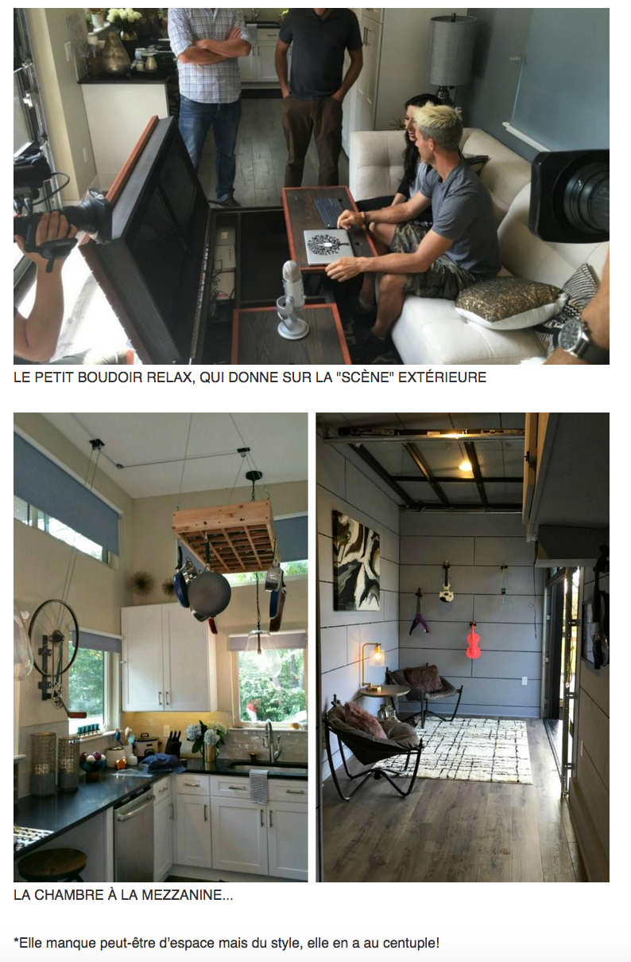

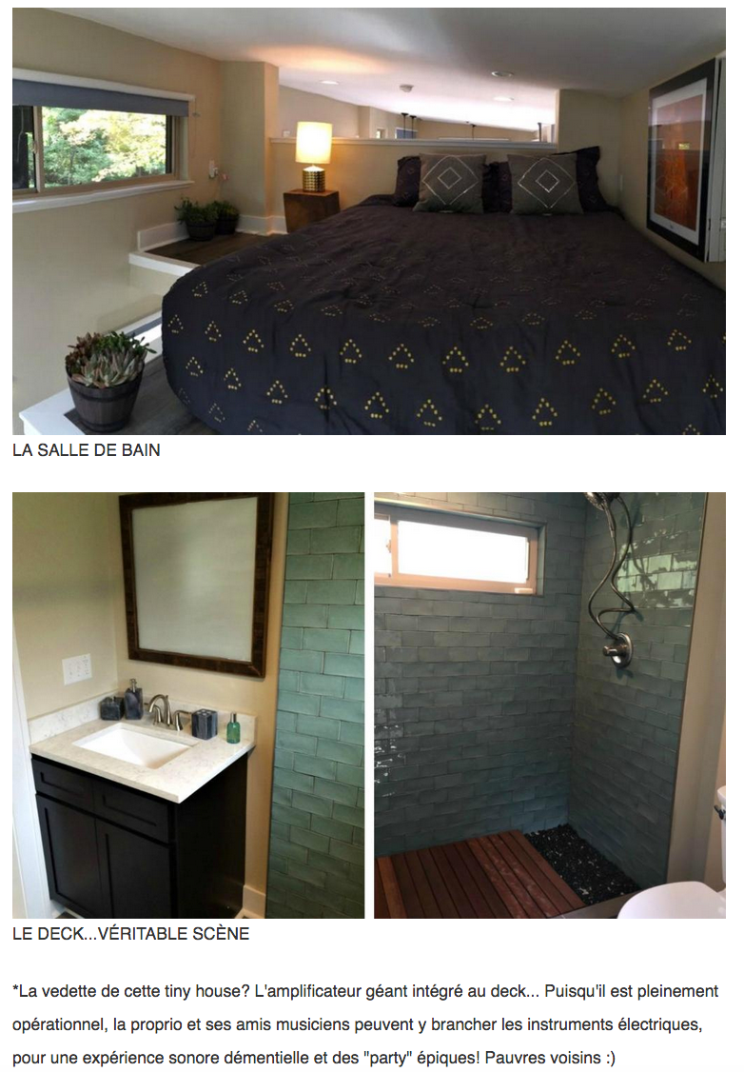

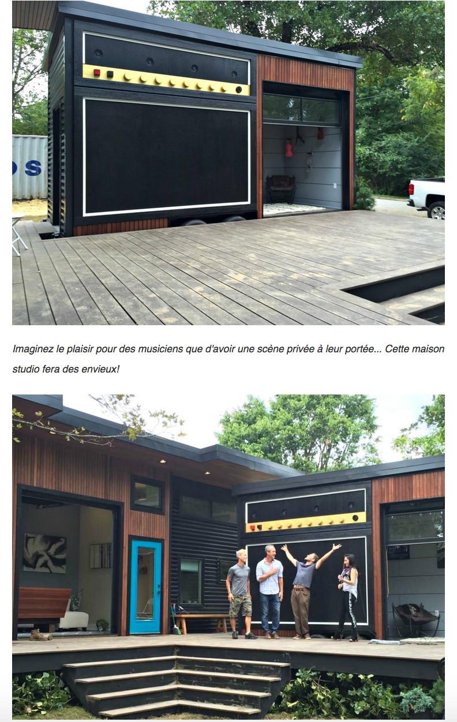

TRANSLATION:

A rocker built a very special tiny house: What she did with her deck will be the envy of all musicians

A rock violinist named Asha Mevlana aspired to a more frugal lifestyle in order to devote her money and energy to her love of music.

His wish? A small but comfortable and pleasant house that could also serve as a studio for the practice of music.
The rendering is a modern mini-house with a contemporary look of great beauty. Nevertheless, the "highlight" of this residential project is undoubtedly the incorporation of a giant amplifier on the deck, which transforms this deck into a performance stage for Asha and his musician friends who use it for their "jam sessions" Weekly :)

Treat yourself to a visit to this "House of Rock" mini:

* This unconventional cottage is narrow but nevertheless perfectly arranged ... A place of importance has been granted to the deck, which allows the owner to make the most of the open air life during the summer period ...

PHOTO CAPTIONS:

In front of the sofa, a large glass door is lifted up like a garage door, for maximum brightness and fresh air ...

To compensate for the lack of space, the furniture has been designed to measure in order to make this interior compact, functional and ventilated ...

Good note for this chest in the living room which, like a magic box, is deployed in supplementary tables while concealing flat screens. Everything is within reach!

She may lack space but style, she has a hundredfold!

The star of this tiny house? The giant amplifier integrated into the deck ... Since it is fully operational, the owner and his musician friends can connect the electric instruments, for a deceptive sound experience and epic "parties"! Poor neighbors :)

Imagine the pleasure for musicians to have a private stage within their reach ... This studio home will envy!

