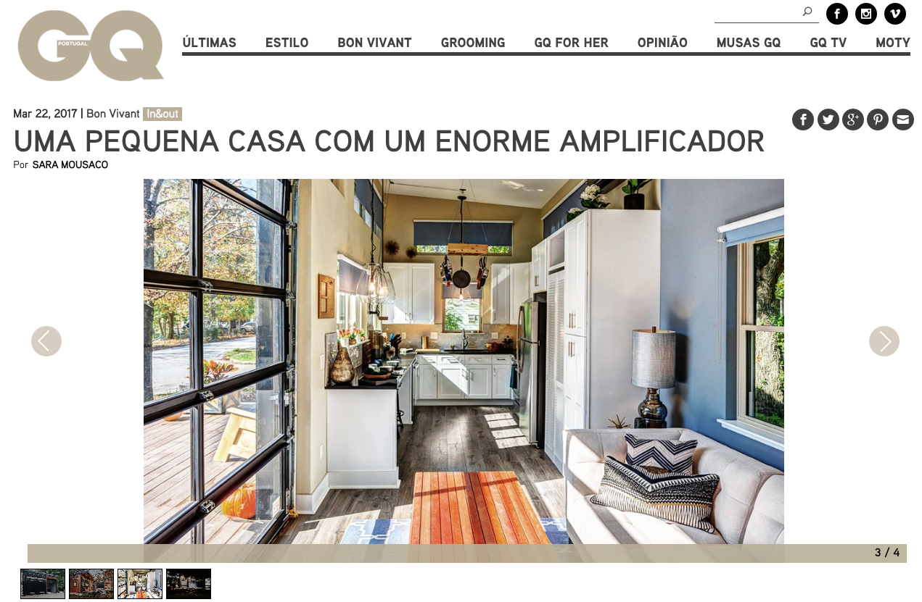

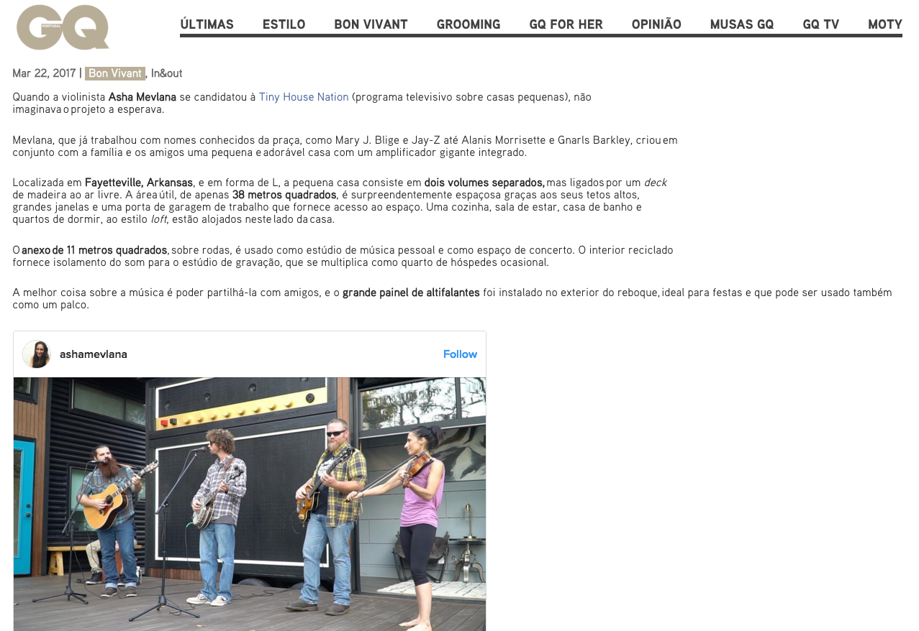

TRANSLATION:

Mar 22, 2017 | Bon Vivant , In & out
When violinist Asha Mevlana applied for the Tiny House Nation , she could not imagine the project waiting for her.
Mevlana, who has worked with well-known names on the square, such as Mary J. Blige and Jay-Z to Alanis Morrisette and Gnarls Barkley, has created a small and lovely house with an integrated giant amplifier in conjunction with family and friends.

Located in Fayetteville, Arkansas , USA and L-shaped, the small house consists of two separate volumes, but connected by an outdoor wooden deck . The floor area of ​​just 38 square meters is surprisingly spacious thanks to its high ceilings, large windows and a working garage door that provides access to the space. A kitchen, living room, bathroom and loft- style bedrooms are housed on this side of the house.

The 11-square-meter annex , on wheels, is used as a personal music studio and as a concert space. The recycled interior provides sound insulation for the recording studio, which multiplies as an occasional guest room.

The best thing about music is being able to share it with friends, and the large speaker panel has been installed on the outside of the trailer, ideal for parties and can also be used as a stage.

