South Fayetteville home featured on ‘Tiny House Nation’ | Fayettevil... https://www.fayettevilleflyer.com/2017/03/10/south-fayetteville-hom...

FRIDAY, MAR. 17, 2017
HOME | NEWS & VIEWS | ARTS, EVENTS & LIFE
South Fayetteville home featured on
‘Tiny House Nation’
By Dustin Bartholomew
March 10, 2017 14K 235
Photo: Don Shreve, Shreve Imaging
If you’ve driven around in south Fayetteville lately, you may have noticed a small, unique looking house at the corner of South Willow
!
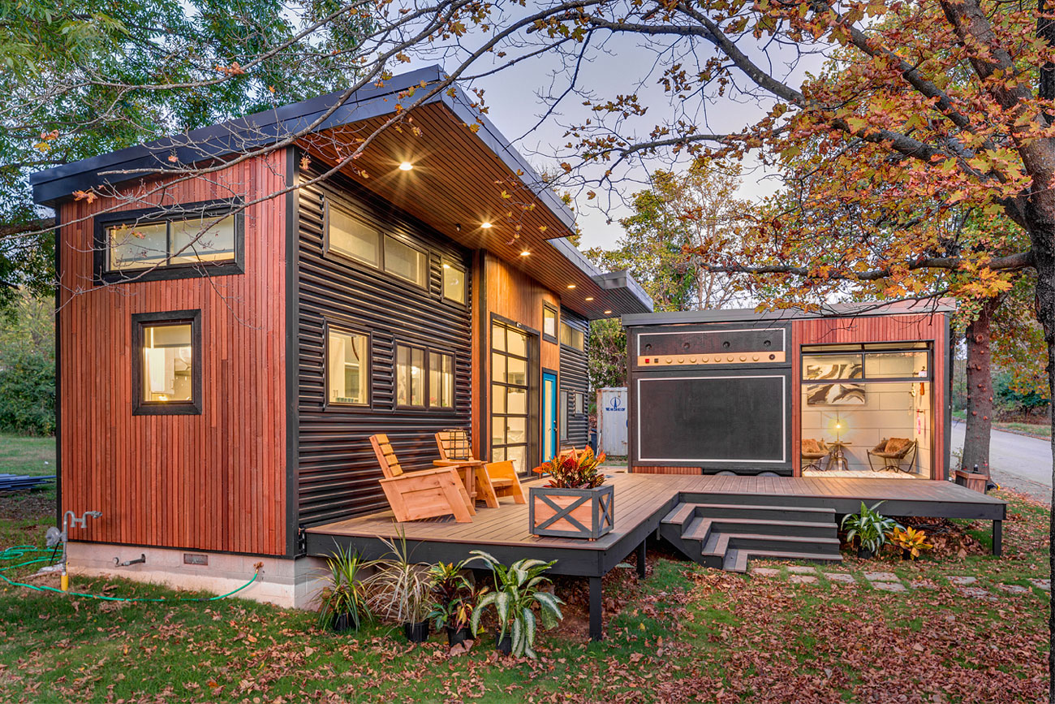
The L-shaped home has an inviting front porch, interesting lighting, and probably most strikingly, a guitar amplifier-shaped facade visible from the road.
It also happens to occupy a total of just over 500 square feet of interior space.
The house was created recently as part of the FYI network show, Tiny House Nation, and the episode featuring it aired earlier this week.
It belongs to Trans-Siberian Orchestra violin player Asha Mevlana who recently moved to town to be close to Asha’s family.

Asha said she knew the show’s co-host, Zack Giffin, and had been a fan of tiny homes for a while. As a New York City resident, she was already used to living in small spaces.
“The idea of building a tiny house has been in my head for a long time,” she said. “And I knew I wanted to move to Arkansas to be near my nephews. I reached out to Zack, and he was like, ‘Yeah, let’s do it.'”
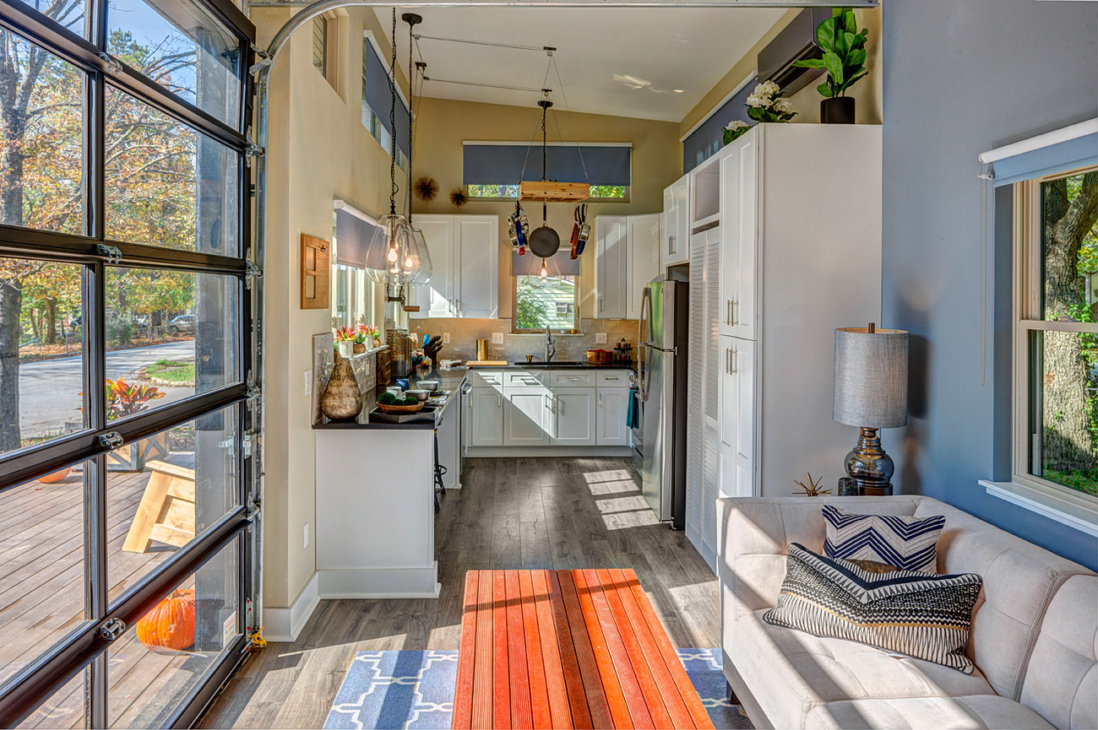
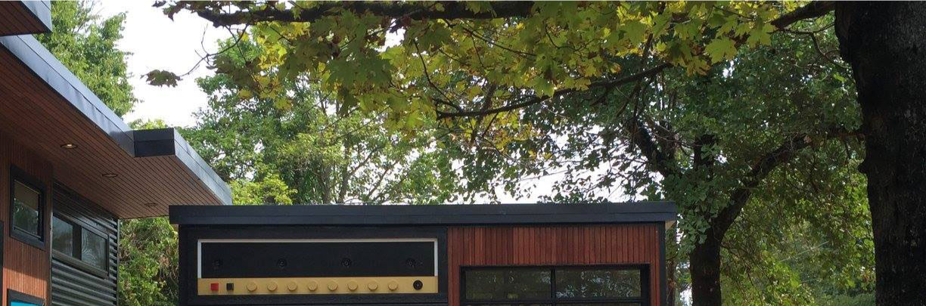
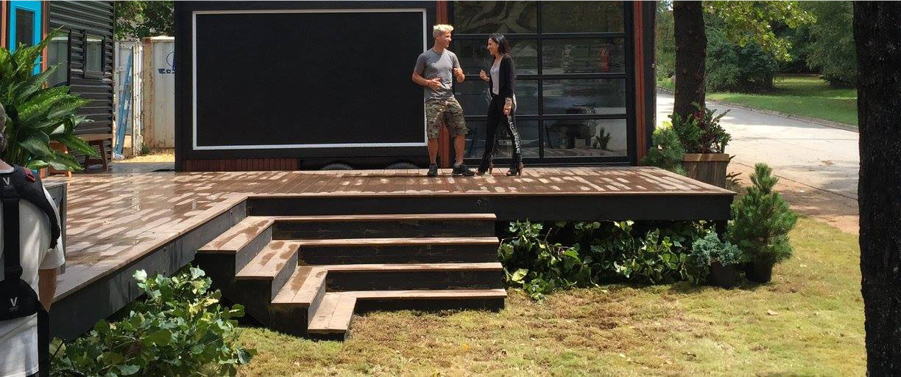
In front of the south Fayetteville tiny house.
Photo: Courtesy, Asha Mevlana
The home was built over the course of about a month in September as part of the television show, with help from local contractor 3VOLVE Housing Co. of Fayetteville and builder Stefan Vickery of Vickery Construction.
The finished home includes a large kitchen, along with a living room, bathroom and a loft-style bedroom. It has high ceilings, and lots of windows for plenty of pleasing, natural light.
Asha said the light in the home has turned out to be among her favorite features.
“I love the light,” she said. “That was one of my biggest concerns, and one of the things Zack recommended was to include a lot of windows.”
The home is also 10 feet wide on a foundation instead of the standard 8 feet on a trailer, another of Zack’s recommendations, which Asha said also makes a huge difference in the spacious feel of the house.
Asha rocking the violin for the cast of Tiny House Nation
Photo: Courtesy, Asha Mevlana
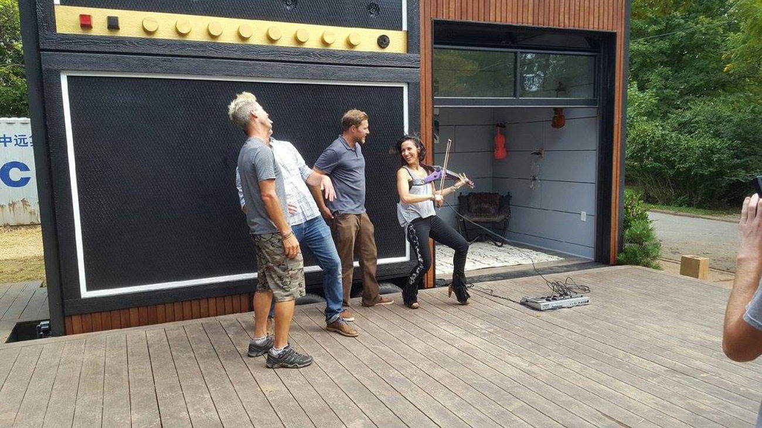

Other interior features include a retractable pot rack made in part with recycled bicycle components, a high-efficiency, low-profile heating and air system, and a coffee table that converts into an editing desk.
There is also a large porch spanning the entire front of the building that creates a nice, outdoor space, and a detached trailer that adds 120 square feet as a studio/guest bedroom/rehearsal space. The amplifier on the front of the trailer actually works when you plug into it, and the trailer can be removed to travel with Asha when she hits the road. It’s also insulated and soundproofed with recycled denim.
Like many folks who move into tiny homes, Asha values experience more than material possessions, which makes the tiny home lifestyle perfect for her. She enjoys traveling as well, and ends up doing so quite a bit for her unique jobs.
“I was just thinking it doesn’t make sense to have a really large house full of a lot of stuff,” Asha said. “It is just so much easier, and it’s nice not to have to worry about rent.”
Asha earlier this week posted several photos, and a brief write up about the home at dwell.com.
See all
