The Day I Fell In Love with a Banana

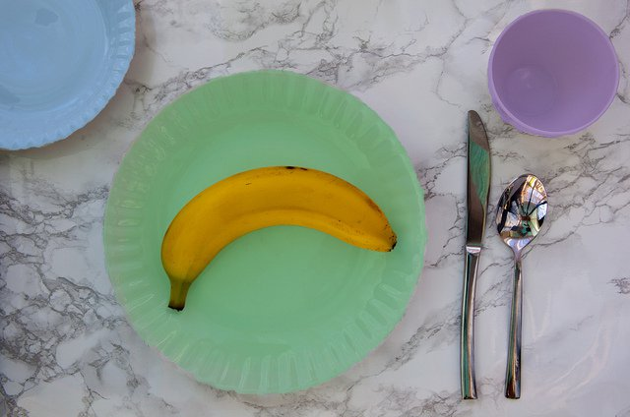

By Asha Mevlana
Oct 19, 2015

~

When I ate, I ate. When I walked, I walked. When I showered, I showered. I was stuck here with nothing to do but be present.

Somehow, in being away from the noise and fast pace of New York City, my entire being slowed down.

It was now the seventh day of a 10-day silent Vipassana meditation retreat. Before arriving here I had never meditated.

Each day had been beyond miserable, and there was not an hour that passed where I didn’t contemplate leaving. But finally now on the seventh day, I was resolved to finish what I had started, if only to tell my friends who thought I couldn’t handle it that I had completed the course.

It was 5 p.m. This was one of the three times I looked forward to during the day—mealtime. However, dinner meant only tea and fruit for new students like me. Old students could only have tea.

As had become custom over the last seven days, I took one banana for dinner, peeled the entire fruit and placed it horizontally on my plate. The bananas looked a couple days too old. I preferred my bananas completely yellow with no signs of brown on the outside. But there were none left and I was ravenous. So I grabbed the banana with the least amount of bruises and sat down at the long wooden table.

I then took a knife and cut the banana into 20 slices. In real life I would gobble down a banana without a second thought, but here, with nothing to do, I had to find ways to entertain myself. And one of those things became trying to see how evenly I could cut a banana into 20 slices.

Once cut, I placed my knife on the right side of my plate. Slowly, I picked up my fork with my left hand and stuck it into the first slice on the left. Lifting it to my mouth, I placed it on my tongue and began to chew.

As I picked up my eighth slice of banana, I looked at the rounded circle in front of me. Or rather, I stared at it. Any outsider peering in at this dining hall might have mistaken it for a psychiatric ward. No one spoke, everything was done in zombie-like slow motion. And there was no emotion in people’s eyes unless they had been crying.

And as I took in what this banana was, I began to cry. I thanked it for being so delicious. For growing and feeding me. I thought of what its life might have been like from a seed until today as a full grown banana with thick yellow and brownish skin.

The flat side of the fruit that my knife had sliced through was slightly shiny. And the rounded edge of the outside was a beige muted color. I examined the lines and shapes in this eighth slice and spun my fork around to admire the beauty in this perfect piece.

Tears now streamed down my face. I felt so much love for this banana and the amount of effort and work it did to grow into this perfect fruit. And I felt such gratitude and appreciation for everything that had gone into helping it grow.

This unconditional love I felt for this banana felt strange, especially for a piece of fruit, but at the time, appropriate. There was no way to fully thank it for providing food and nourishment to my body.

I felt badly that I had originally judged it when I first took it from the fruit bowl. It tasted delicious and sweet just as I would want my banana to taste. And whether it was bright yellow or completely brown, it was perfect just as it was.

I realized that I could almost be speaking about myself. I judged myself all the time. I was far from what I would consider perfect. But at that moment I decided to give myself that same outpouring of unconditional love as I had for this fruit in front of me. I had grown from a little seed into an adult. I was perfect exactly how I was in that moment and I would be perfect exactly how I was a year from now or 10 years from now.

I thanked the banana for coming into my life. It would never know that just by being exactly what it was, it had changed something inside me. This overwhelming compassion I felt for this banana had taught me how to love and have compassion for myself.

