The Little Living Blog: Amplified Tiny House (520 Sq Ft)
http://www.littlelivingblog.com/2017/03/amplified-tiny-house-520-sq...

AMPLIFIED TINY HOUSE (520 SQ FT)
MARCH 03, 2017
This gorgeous tiny house is composed of two structures: a main house on a foundation and a trailer, joined by a deck.
The main home spans 400 sq ft and the trailer has 120 sq ft, which gives the home a combined size of 520 sq ft. The
main home features a kitchen, living room, loft bedroom, and bathroom.
The trailer is used as a guestroom and sound studio. It's sound-proofed with denim, and utilizes a high ceiling
and glass garage door to make the small space seem bigger. There's also speakers on the front of the home which
allows the whole trailer to be a sound system!

You can see the home on Tiny House Nation tomorrow, March 4th, on the FYI Network at 9/8pm central.

ABOUT
Welcome to Little Living Blog!
A place to share and enjoy small homes and spaces, between 500 to 1000 sq ft.
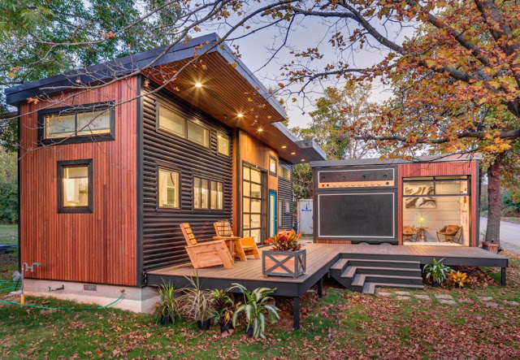
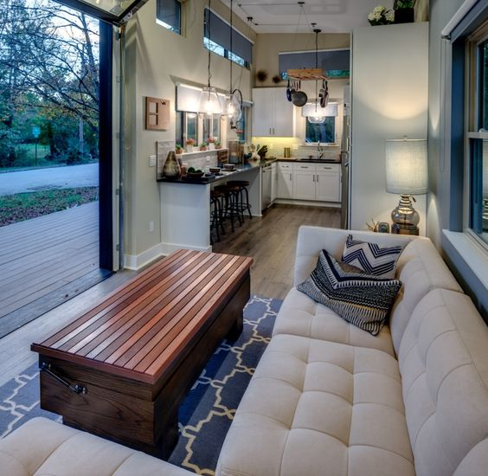
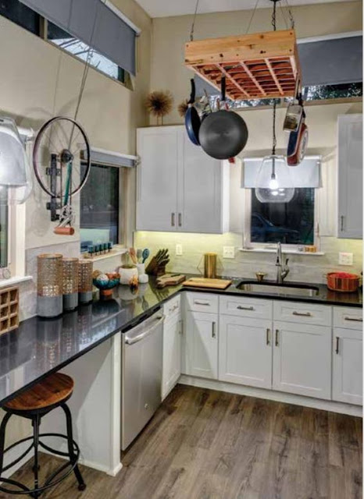
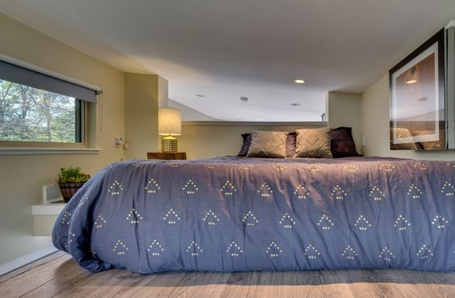
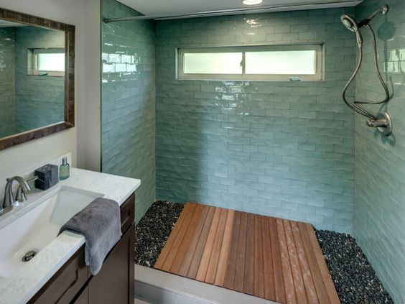
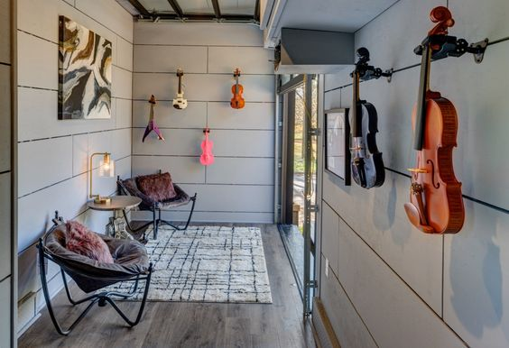

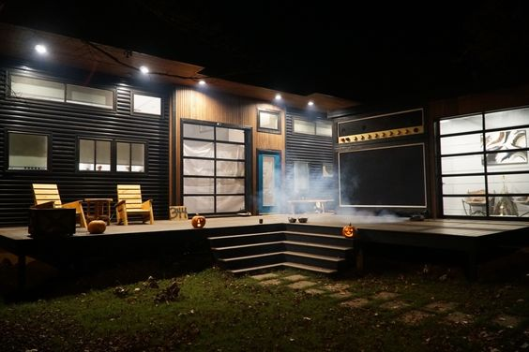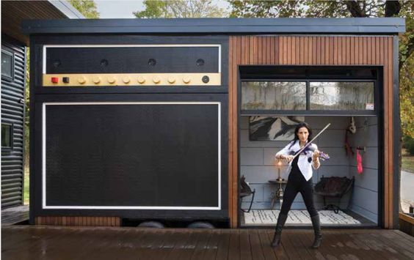
Join the Little Living Blog on: Instagram | Facebook | Pinterest Images © Don Shreve, via Dwell

