http://inhabitat.com/amplified-tiny-house-lets-musician-homeowner-...
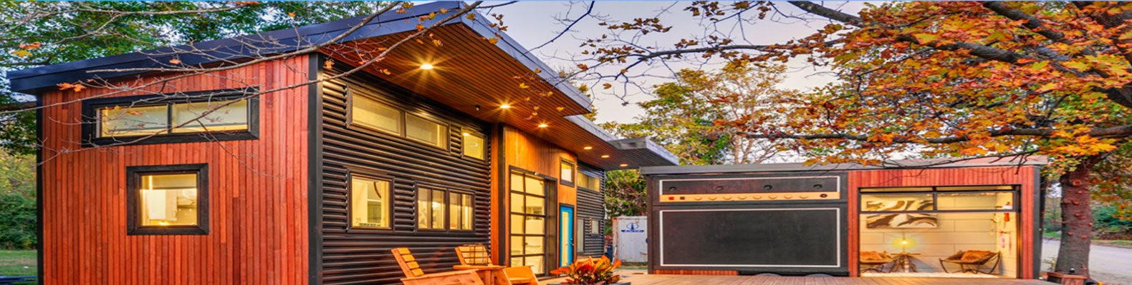
Amplified tiny house lets musician homeowner rock out in the great outdoors
03/08/2017 under Architecture, carousel showcase, Gallery, Tiny Homes 1 Like 1.7K Flip by Nicole Jewell
Electric violin player Asha Mevlana wanted a home that combined her love of music with her need to scale down her lifestyle – so she came up with the idea for an “amplified” tiny home. With help from the team behind Tiny House Nation, the musician was able to build a compact 400-square-foot tiny home divided into two spaces – one side for living and the other equipped with a huge amplifier for rocking out on the front deck.
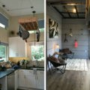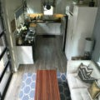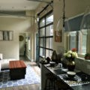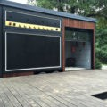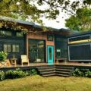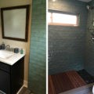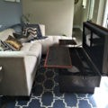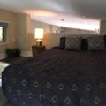

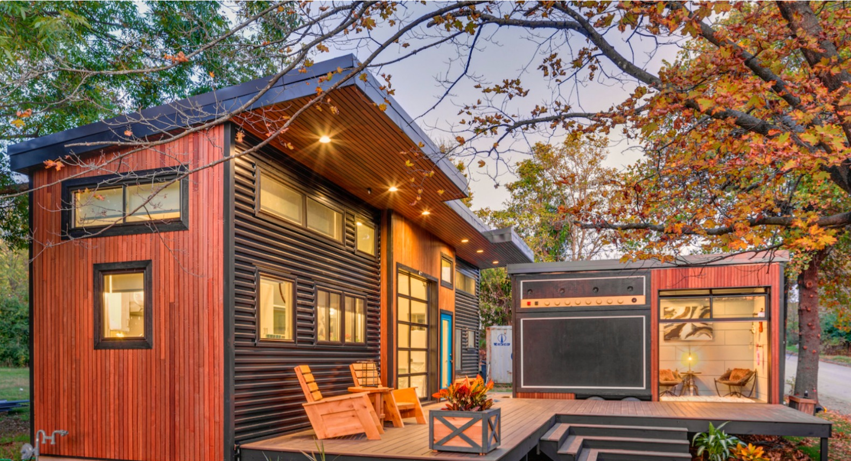
Located in Fayetteville, Arkansas, Mevlana’s L-shaped tiny home consists of two separate volumes
joined by an open-air wooden deck. The living space, which is just 280 square feet, is surprisingly
spacious thanks to its high ceilings, large windows and a working garage door that provides access to
the deck. A large kitchen, living room, bathroom and loft-style sleeping area are housed on this side
of the home. The patio furniture is by Ecovet Furniture, which sells custom furniture built by veterans
using reclaimed wood from decommissioned trailers.

Adjacent to the living quarters is a separate 120-square-foot trailer on wheels, which is used as the musician’s
personal music studio and concert space. On the inside, recycled denim provides soundproofing for her recording
studio, which also serves as an occasional guest bedroom. Of course, the best thing about music is sharing it with
the ones you love, so a large panel of weather-proof marine speakers was installed on the trailer’s exterior.
When the mood strikes, Mevlana and her musician friends can plug electric instruments into the panel to rock out
on the deck-cum-stage.
