Meditation—a Rebirth.

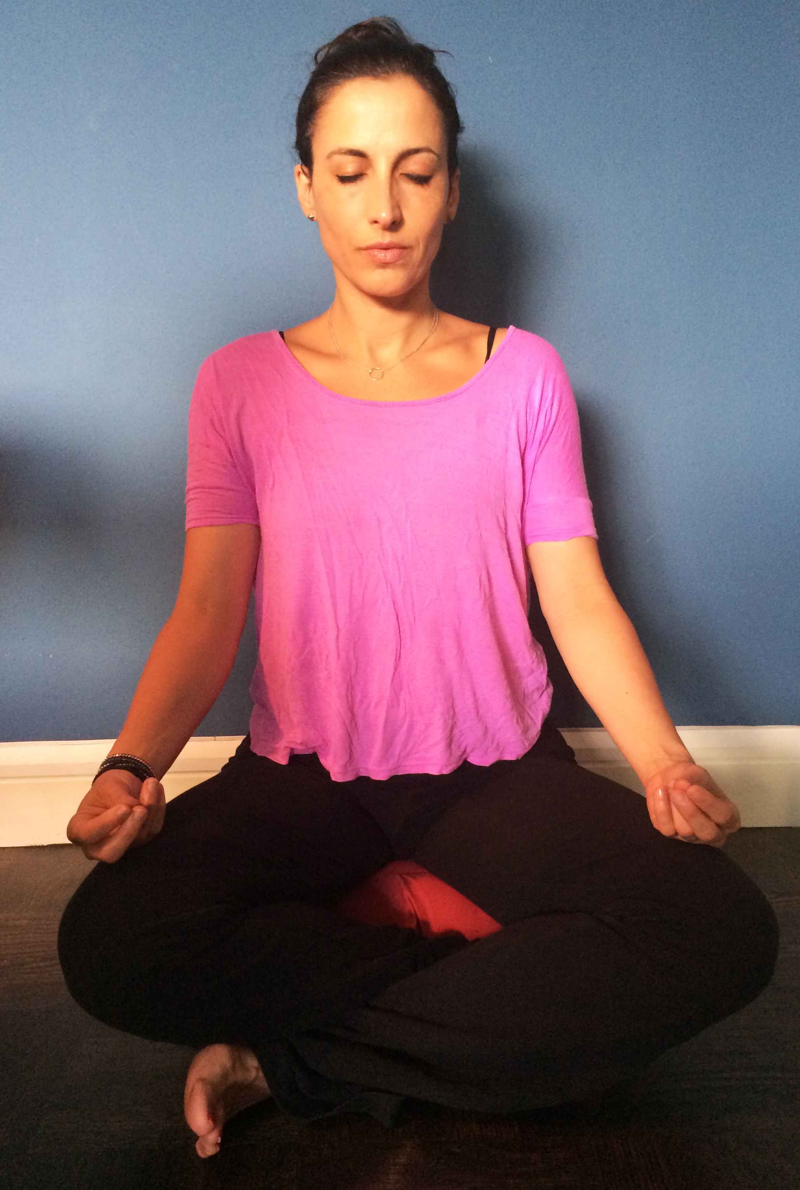

By Asha Mevlana
May 1, 2015

If you asked my mom, she would say I was born on October 29, 1975.
But it wasn’t until December 15, 1999 at 9:12a.m. that I truly started living.
That was the morning I was diagnosed with breast cancer and thought I might be dying. Not knowing whether I would survive to my next birthday, I made a promise to myself that I would do all the things I’ve never done but always wanted to do.
My favorite quote from high school by Thoreau became my motto and every opportunity that presented itself I took just for the experience.

“I went to the woods to live deliberately… to live deep and suck the marrow out of life… and not when I came to die discover that I had not lived.”
~ Henry David Thoreau

12 years later, I had everything I had wanted and wished for and still it wasn’t enough.
I wasn’t happy. I wanted more, more, more.
Opportunities and things to do on my life checklist such as playing the Star Spangled Banner on my violin for a Red Sox game, learning to dance, climbing Mt. Everest, writing a book, were endless. I couldn’t wait to finish one experience, so I could check it off and move onto the next.
My life had become a list where I was never quite present in anything I did.

I signed up for a 10-day silent meditation course as another thing to “experience” before I died. It was 10 days of pure torture, meditating for up to 12 hours a day with no outside contact, no reading, writing, emails or phone calls. It was physically and emotionally draining—like a boot camp for the mind.
I hated every second of every day. The misery was unlike anything I had ever felt and thoughts of escaping crossed my mind daily.
But on the 9th day, as I sat on my blue cushion, something changed inside me.
I don’t know how and I don’t know why, but I began sobbing. Tears poured out of me uncontrollably. They were tears of happiness because for the first time in 36 years, I felt a genuine and intense love for myself.
True, unconditional love.
I realized that I had been looking for external happiness for years, perhaps my entire life. I thought I needed constant outside adrenaline to make me feel alive, but I had never discovered peace and happiness within.
On this 9th day, I surrendered for the second time to something higher in my life, the first being diagnosed with breast cancer.
I once again made a promise to myself, but this time it wasn’t about getting things done.

It wasn’t about living big and accomplishing “more” but rather seeing the beauty in stillness and sometimes nothingness that I had come to loathe over the years.
It was a reawakening and a rebirth.
One of living in the moment, of being kind and gentle to myself and appreciating the small things once again, something I had somehow lost track of on my mission to “experience” life.
Ironically it was only now that I would begin to really suck the marrow out of life, realizing that happiness had never been external.
And it was only now that I would be able to find that true inner peace that I had been searching for all along.

