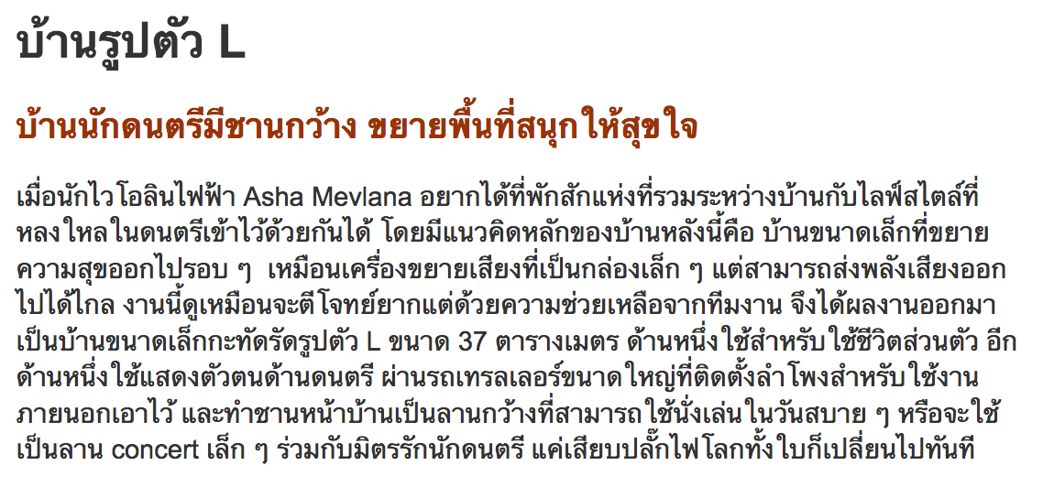
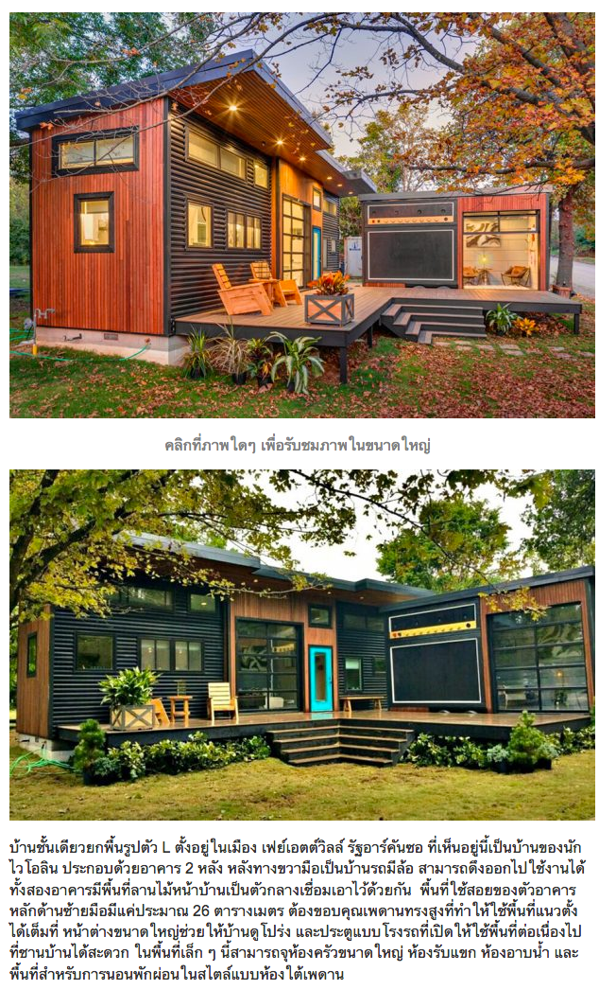
TRANSLATION:

One-storey house, wide terrace, nice to have a concert.

Musicians have a broad range of musicians. Expand the fun area to enjoy.

When electric violinist Asha Mevlana wants to have a place to relax in between a home and a passionate musical lifestyle. The main concept of this house is. A small home that blends in and out like a small box amplifier, but delivers far more power. This work seems to be difficult but with the help of the team. It works out to be a small house size L size 37 square meters, one for personal use. The other side is the musical identity. Through a large trailer with external speakers installed. And the front yard is a large patio that can be used for a casual day or a small concert hall with a friendly musician. Just plug the power to the whole world suddenly changed.

L-shaped single-storey house located in the city. Fayetteville, Arkansas, is the home of the violinist. Consists of 2 buildings on the right hand side. Can be pulled out to work. Both buildings have a wooden front yard as a connecting medium. The living area of ​​the main building on the left hand side is only about 26 square meters, thanks to the high ceilings that make up the vertical area. Large windows make the house look airy. And a garage door that opens up to the patio area. In this small space, it can accommodate large kitchens, living rooms, showers and sleeping areas in the under-the-ceiling style.

On the day of fresh air, breeze and morning sunlight - in the evening. It opens the glass door.

Part of the room on the car looks like an amphibious car. The 11 square meter living space is a studio, music composition, concert and concert space. The inner walls use recycled denim to help with the sound of the studio recording. Sometimes this is also used as a guest bedroom. And of course, musicians want to share the music because the people we love to listen together. The designer creates a large, waterproof outdoor speaker that connects to the patio. This makes it a small stage when home owners want to play music with friends when it is not difficult. Just go to the plug and ready to open the concert.

The kitchen area is the same as the living room. Even though it is a small square, the corner kitchen provides plenty of space in the middle of the kitchen and living room with windows and electric glass doors. The transparency of the glass fill the airiness. Reduce the awkwardness of solid walls. Make the house more open and wide.

With limited space. The choice of furniture must be appropriate for the room. Here is a white sofa with a corner L-size of 5-6 seats for the members of the music can sit at the same time several people. The center table is specific to the multifunction. Can open the store. Pull out easily. It is a small house, but it is the beginning of a great relationship. Make all the creation of the song full of fun.

Small bathrooms are decorated with white glossy tiles. To see the room wider. With less space, take a shower instead of a bathtub. Which is popular in almost every American home.

The bedroom was raised to become an attic. Do not disturb the allocation of the bedroom. The bottom area can be used in other areas as a narrow service area solution for both horizontal and vertical use.

